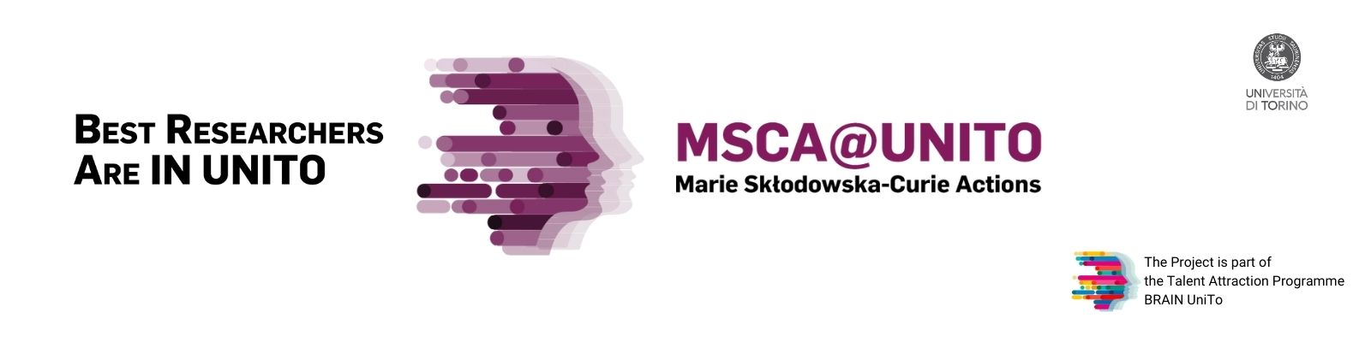
Short proposal
Marie Skłodowska Curie Actions - Postdoctoral Fellowships

Last name | Type of grant *
First name | European Fellowship / Global Fellowship

Tentative Title | Please indicate a tentative title
Name of the supervisor | Please indicate the name of your supervisor according to the following indications:  - European Fellowship: indicate the name of your supervisor at University of Turin  - Global Fellowship: indicate the name of your supervisor at University of Turin and the name of the supervisor host institution in the third country (if already chosen)
Estimated duration | European Fellowship: normally 24 months / Global Fellowship: normally 36 months

Abstract of your proposal: Please follow the suggested sections, also considering the guiding questions below.
Approx. 8000 characters

a) Background/context of your proposal (1 paragraph)
Indicate the field of research, the major problem/challenge/gap your project is addressing, and why your project is innovative against the state-of-the-art in the field(s) considered.
- Which challenges will you address with your research? Why now?
- Is the proposed research beyond the state-of-the-art?

b) Overview of the proposal (1 paragraph)
Indicate the main objective of your project proposal and possibly 3-4 sub-objectives. Write a sentence indicating the elements of novelty of your proposal.
- What are your objectives/aims?
- What is the novelty of the approach, methodology etc. ?

c) Scientific impact (1 paragraph)
Indicate your solution in relation to the major problem/challenge indicated in section a) and the main result(s) expected
- What new knowledge/understanding does this research project produce?
- How the results will influence further theory/methodological developments?

d) Impact on your career (1 paragraph)
Indicate your expertise in relation to the proposed research and the new competences you expect to acquire throughout the Marie Curie project.
- Why you? Can your CV prove that you have the ability to implement your research project?
- Which are the expected results on your career after the end of the fellowship?
- Which are the competences you expect to acquire thanks to the contribution of your supervisor(s) and the research activities you will carry out?

